SQL Assignment 1
Student Name | Malik Muhammad Bilal | Roll No. | 925127
Part 1
1.1 Display all columns and all rows from the Customers table.
SELECT *  FROM dbo.Customers; | 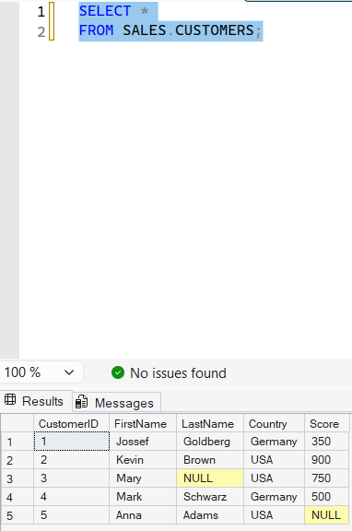

1.2 Display only the FirstName, LastName and Country of all customers.
SELECT  FIRSTNAME,  LASTNAME,  COUNTRY  FROM dbo.Customers | 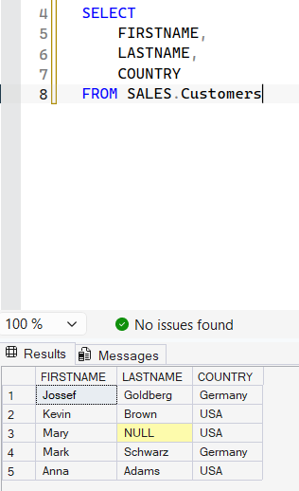

1.3 Display the ProductName and Price of all products. Rename the output columns as Product and UnitPrice.
select  product_name as Product,  list_price as UnitPrice  From production.products; | 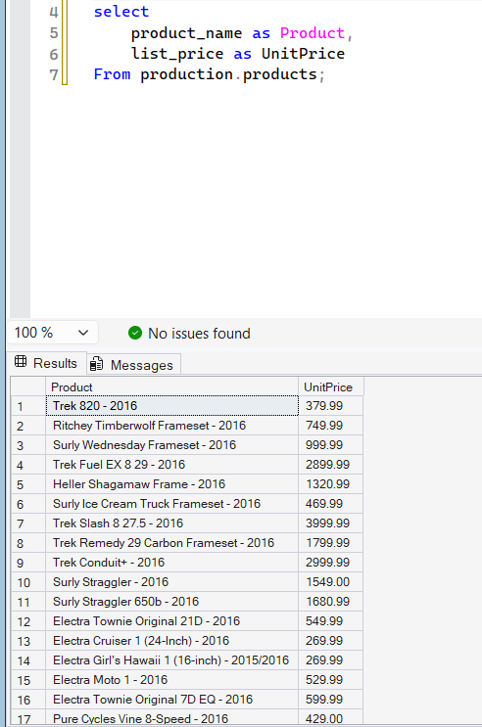

1.4 Display the list of countries where our customers live. Each country must appear only once.
select distinct country  from dbo.Customers  order by Country desc; | 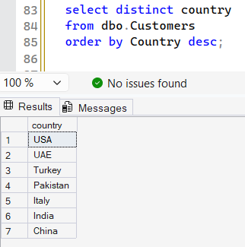

1.5 Display each employee's FirstName, Salary and a new column called SalaryAfterRaise that shows the salary increased by 10%.
SELECT  FIRSTNAME,  SALARY,  SALARY * 1.10 AS SALARY_INCREASED  FROM SALES.EMPLOYEES | 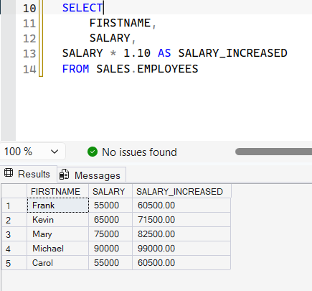

Part 2
2.1 Display all customers who live in Pakistan.
SELECT *  FROM dbo.Customers  WHERE Country = 'PAKISTAN' | 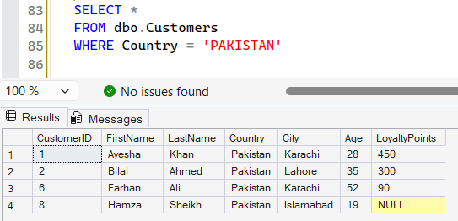

2.2 Display the ProductName and Price of all products that cost more than 100.
SELECT  product_name,  LIST_PRICE  FROM production.Products  WHERE List_price > 100; | 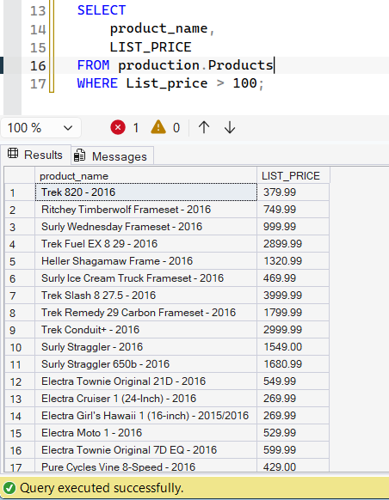

2.3 Display the FirstName, Department and Salary of employees who earn 60000 or less.
SELECT  FIRSTNAME,  DEPARTMENT,  SALARY  FROM Sales.Employees  WHERE Salary <= 60000; | 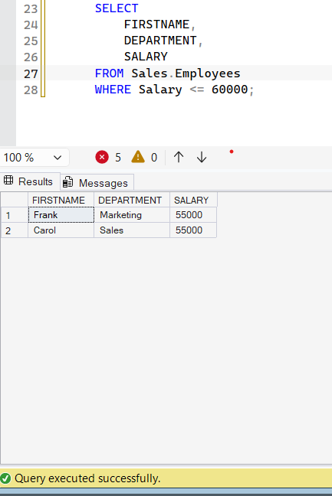

2.4 Display all orders whose Status is not 'Cancelled'.
SELECT *  FROM sales.orders  WHERE OrderStatus <> 'Cancelled'; | 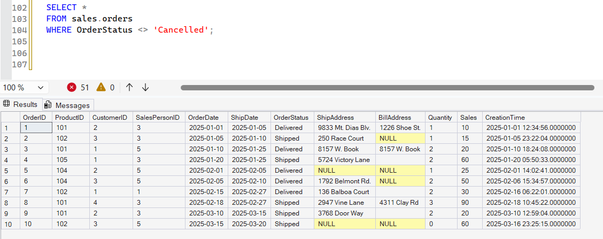

2.5 Display the FirstName and LastName of customers whose LoyaltyPoints value is missing (NULL).
SELECT  FirstName,  LastName  FROM dbo.Customers  WHERE LoyaltyPoints IS NULL; | 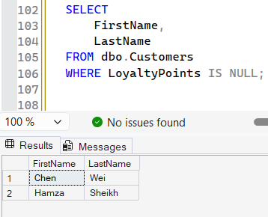

Part 3
3.1 Display ProductName and Price of all products, sorted from the lowest price to the highest price.
SELECT  PRODUCT_NAME AS PRODUCTS,  LIST_PRICE AS PRICE  FROM PRODUCTION.PRODUCTS  ORDER BY list_price ASC; | 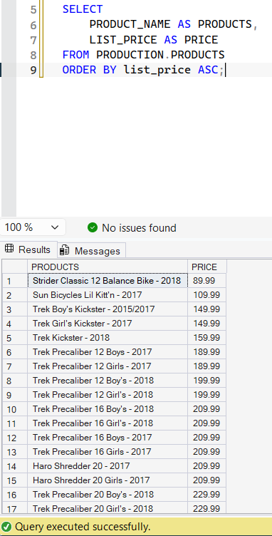

3.2 Display FirstName and Age of all customers, sorted from the oldest to the youngest.
SELECT  FIRSTNAME,  AGE  FROM dbo.Customers  ORDER BY AGE DESC; | 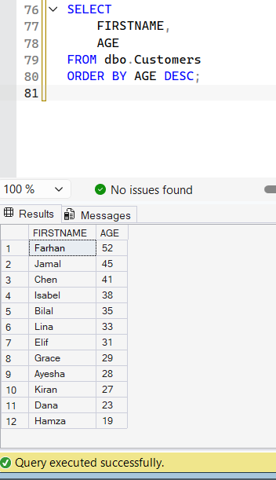

3.3 Display all employees sorted alphabetically by LastName (A to Z).
SELECT *  FROM Sales.Employees  ORDER BY LastName ASC; | 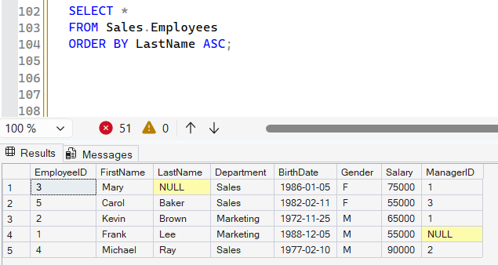

3.4 Display FirstName, Country and LoyaltyPoints of all customers. Sort them by Country (A to Z) and, within the same country, by LoyaltyPoints from highest to lowest.
SELECT  FirstName,  Country,  LoyaltyPoints  FROM dbo.Customers  ORDER BY Country ASC, LoyaltyPoints DESC; | 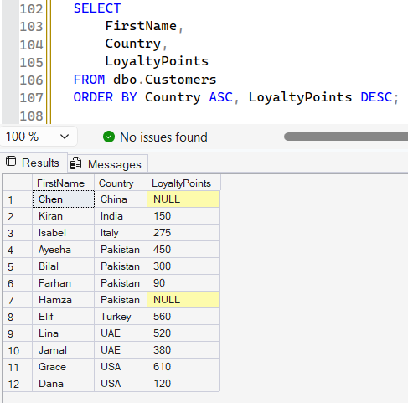

3.5 Display OrderID, OrderDate and Amount of all orders whose Status is 'Delivered', with the most recent order first.
SELECT  OrderID,  OrderDate,  Amount,  status  FROM dbo.Orders  WHERE Status = 'Delivered'  ORDER BY OrderDate DESC; | 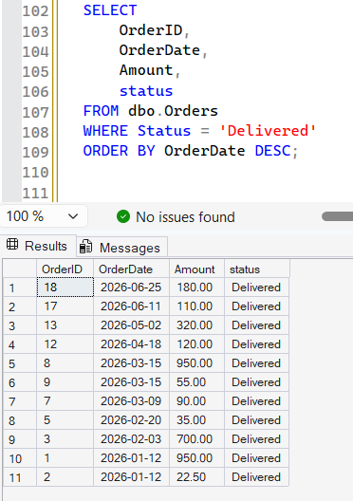

Part 4
4.1 Display customers who live in Pakistan AND are older than 30.
SELECT *  FROM dbo.Customers  WHERE Country = 'PAKISTAN' AND Age > 30  ORDER BY Age ASC; | 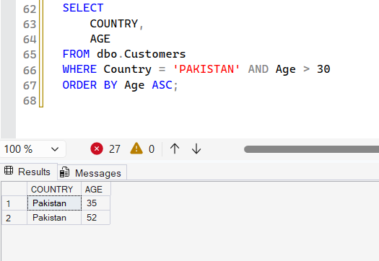

4.2 Display products that belong to the 'Furniture' category OR cost less than 10.
SELECT *  FROM dbo.Products  WHERE Category = 'FURNITURE'  OR Price < 10; | 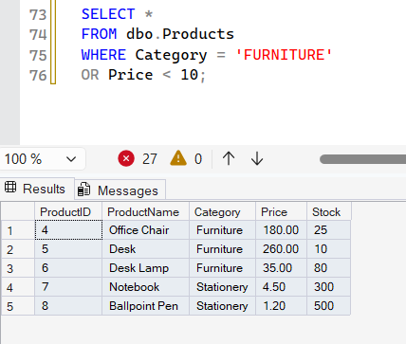

4.3 Display employees who work in the 'Sales' department AND earn more than 50000.
SELECT * FROM dbo.Employees  WHERE Department = 'SALES'  AND Salary > 50000; | 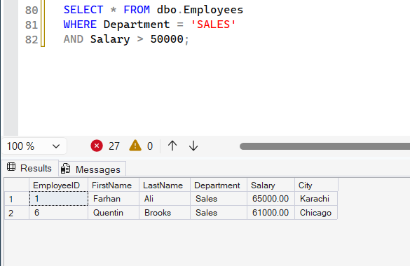

4.4 Display customers who do NOT live in Pakistan. Use the NOT operator.
SELECT *  FROM dbo.Customers  WHERE NOT Country = 'PAKISTAN'; | 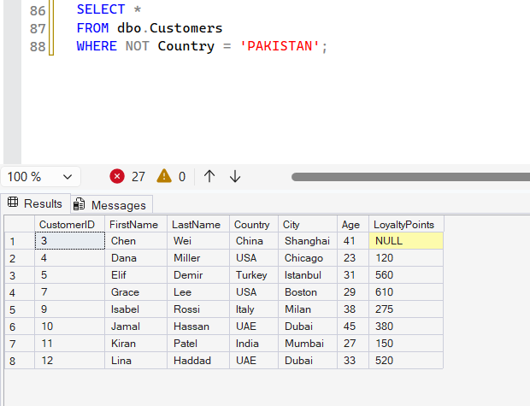

4.5 Display customers who live in the USA or the UAE and who have more than 400 LoyaltyPoints. (Hint: use brackets.)
SELECT *  FROM dbo.Customers  WHERE (Country = 'USA' OR Country = 'UAE')  AND LoyaltyPoints > 400; | 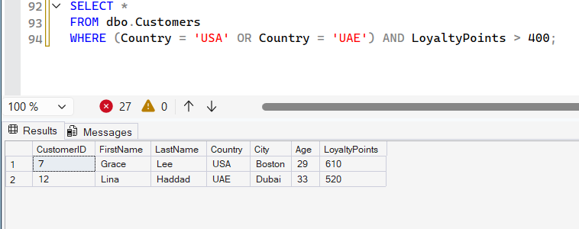

Part 5
5.1 Display the first 3 rows of the Customers table.
SELECT TOP 3 *  FROM dbo.Customers; | 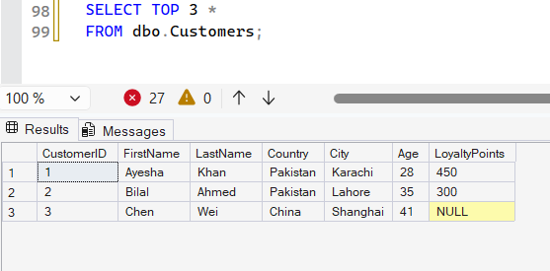

5.2 Display the ProductName and Price of the 5 most expensive products.
SELECT TOP 5  ProductNAME,  PRICE  FROM dbo.Products  ORDER BY PRICE DESC; | 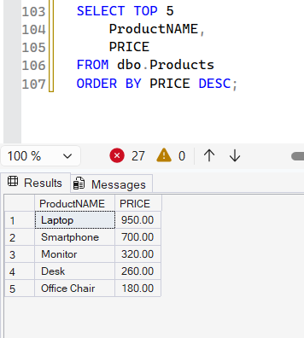

5.3 Display the FirstName and Age of the 3 youngest customers.
SELECT TOP 3  FIRSTNAME,  AGE  FROM dbo.CUSTOMERS  ORDER BY AGE ASC; | 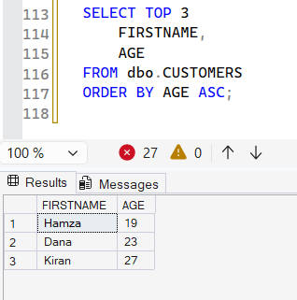

5.4 Display the FirstName, LastName and Salary of the highest-paid employee (only one row).
SELECT TOP 1  FirstName,  LastName,  Salary  FROM DBO.Employees  ORDER BY Salary DESC; | 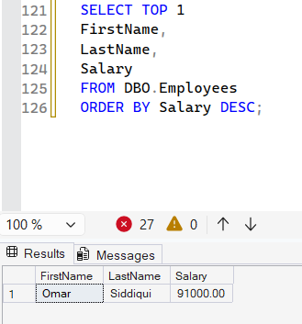

5.5 Display OrderID, OrderDate and Amount of the 2 most recent orders whose Status is 'Delivered'.
SELECT TOP 2  OrderID,  OrderDATE,  AMOUNT  FROM dbo.Orders  WHERE Status = 'DELIVERED'  ORDER BY OrderDate DESC; | 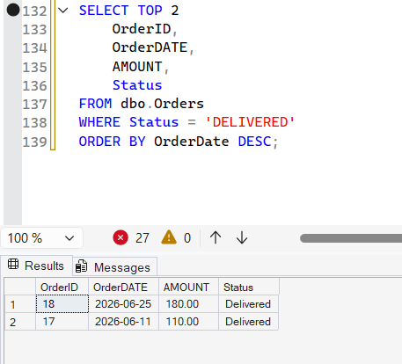

Part 6
6.1 Using UNION, display one combined list of FirstName and LastName of all customers and all employees. A person who appears in both tables must be shown only once.
SELECT  FIRSTNAME,  LASTNAME  FROM dbo.Customers  UNION  SELECT  FIRSTNAME,  LASTNAME  FROM dbo.Employees; | 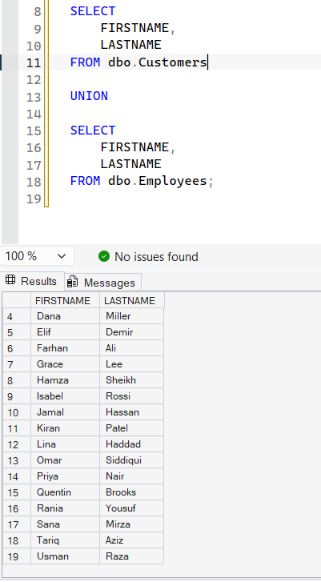

6.2 Write the same query using UNION ALL. How many more rows do you get compared with Question 6.1, and why? (Write your answer as a comment after the query.)
SELECT *  FROM dbo.Customers  WHERE Country = 'PAKISTAN'  SELECT  FIRSTNAME,  LASTNAME  FROM dbo.Customers  UNION ALL  SELECT  FIRSTNAME,  LASTNAME  FROM dbo.Employees; | 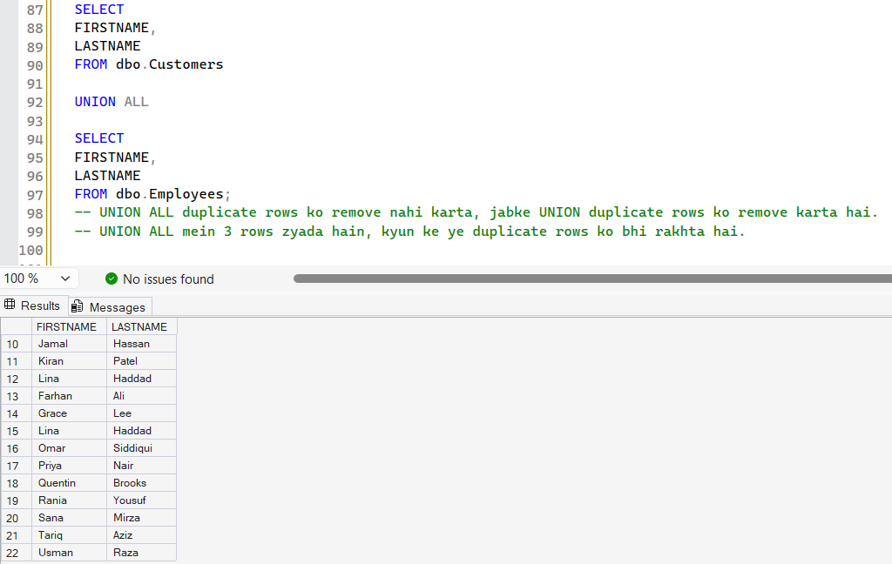

6.3 Using INTERSECT, display the FirstName and LastName of people who are both a customer and an employee.
SELECT  FIRSTNAME,  LASTNAME  FROM dbo.Customers  INTERSECT  SELECT  FIRSTNAME,  LASTNAME  FROM dbo.Employees; | 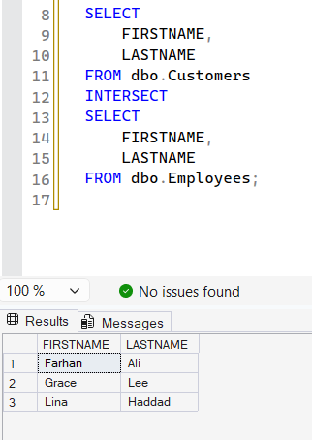

6.4 Using EXCEPT, display the FirstName and LastName of customers who are not employees.
SELECT  FIRSTNAME,  LASTNAME  FROM dbo.Customers  EXCEPT  SELECT  FIRSTNAME,  LASTNAME  FROM dbo.Employees; | 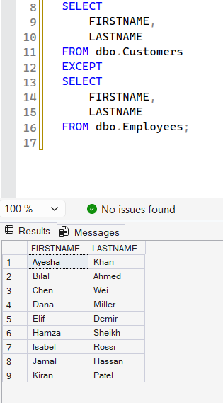

6.5 Using UNION ALL, display FirstName, LastName and an extra column called PersonType that shows 'Customer' for customers and 'Employee' for employees. Sort the final result by FirstName.
SELECT  FIRSTNAME,  LASTNAME,  'CUSTOMER' AS PersonType  FROM dbo.Customers  UNION ALL  SELECT  FIRSTNAME,  LASTNAME,  'EMPLOYEE' AS PersonType  FROM dbo.Employees  ORDER BY FirstName ASC; | 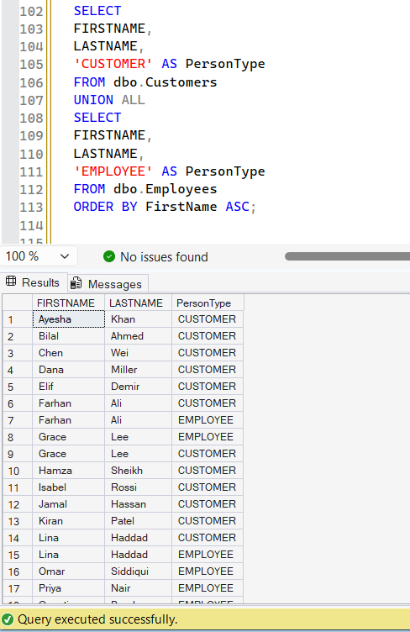

Part 7
7.1 Display customers who live in Pakistan, UAE or India. Use IN.
SELECT  FIRSTNAME,  LASTNAME,  COUNTRY  FROM dbo.Customers  WHERE Country IN ('PAKISTAN', 'UAE', 'INDIA'); | 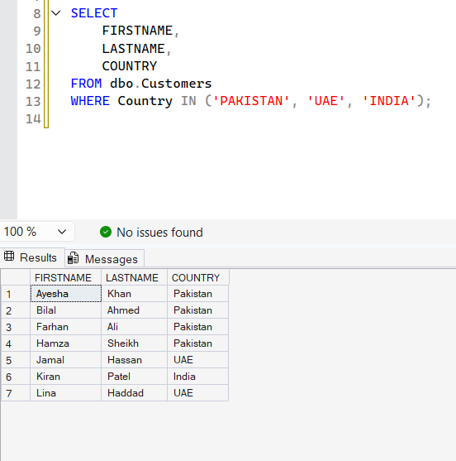

7.2 Display ProductName and Category of products whose category is either 'Stationery' or 'Accessories'. Use IN.
SELECT  productname,  category  FROM dbo.Products  WHERE Category IN ('Stationery','Accessories'); | 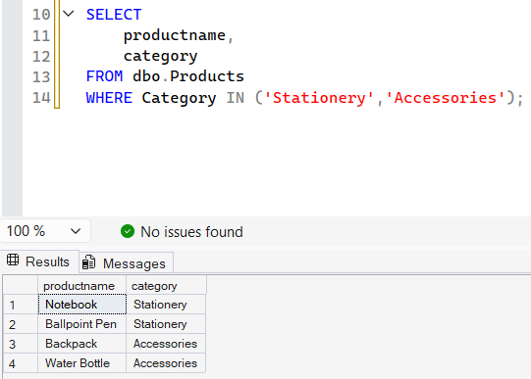

7.3 Display customers who do not live in the USA, China or Italy. Use NOT IN.
SELECT  FIRSTNAME,  LASTNAME,  COUNTRY  FROM dbo.CUSTOMERS  WHERE COUNTRY NOT IN ('USA','CHINA','ITALY'); | 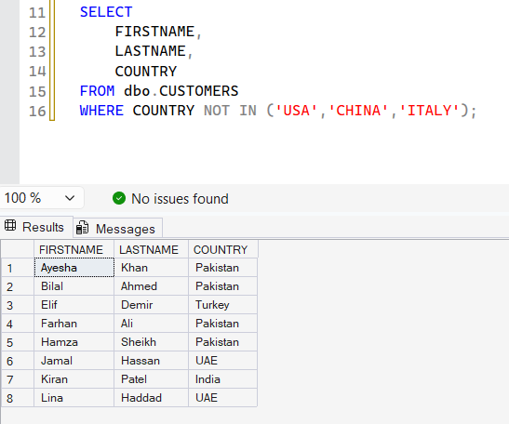

7.4 Display FirstName, Department and Salary of employees who work in 'HR' or 'Marketing', with the highest salary first.
SELECT  FIRSTNAME,  SALARY,  DEPARTMENT  FROM dbo.Employees  WHERE Department IN ('HR','MARKETING')  ORDER BY SALARY DESC; | 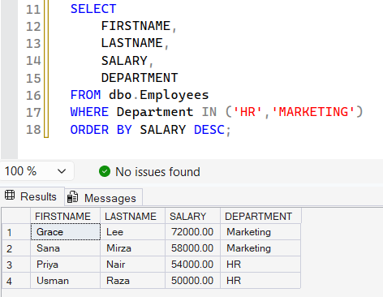

7.5 Display all orders whose Status is neither 'Cancelled' nor 'Pending'. Use NOT IN.
SELECT  *  FROM dbo.Orders  WHERE Status NOT IN ('Cancelled','Pending'); | 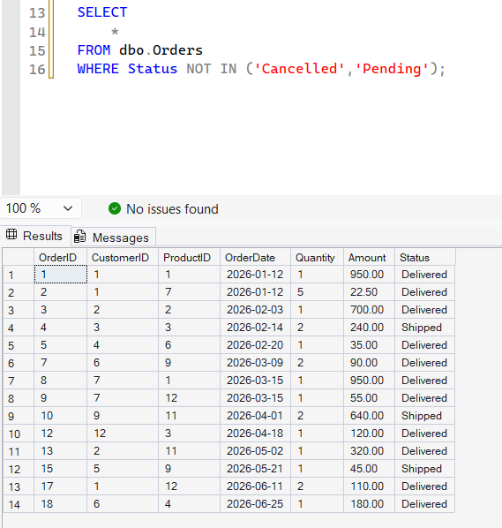

Part 8
8.1 Display OrderID, the customer's FirstName and the OrderDate for every order. (Join Orders and Customers.)
SELECT  Customers.FirstName,  Orders.OrderID,  Orders.OrderDate  FROM dbo.Customers  JOIN dbo.Orders  ON Customers.CustomerID = Orders.CustomerID; | 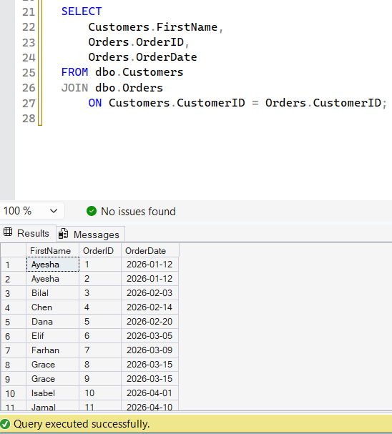

8.2 Display every customer's FirstName together with the OrderID of their orders. Customers who have never ordered must also appear (their OrderID will be NULL).
SELECT  Customers.FirstName,  Orders.OrderID  FROM dbo.Customers  LEFT JOIN dbo.Orders  ON Customers.CustomerID = Orders.CustomerID; | 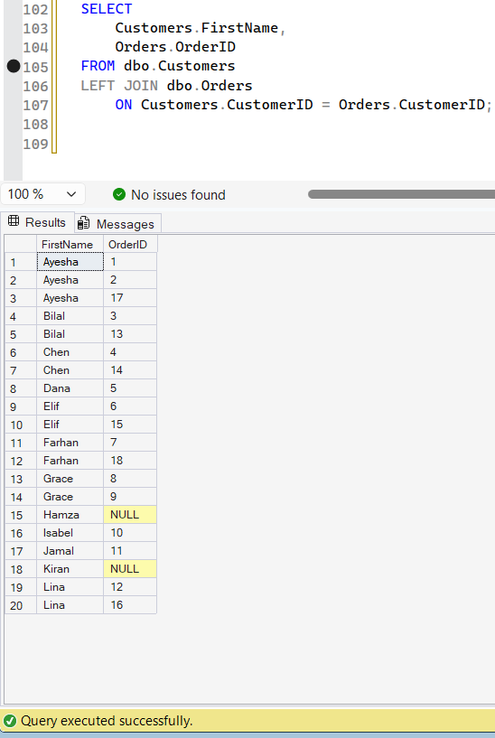

8.3 Display every product's ProductName together with the OrderID in which it was sold. Products that were never ordered must also appear. Use a RIGHT JOIN and start from the Orders table.
SELECT  Products.ProductName,  Orders.OrderID  FROM dbo.Orders  RIGHT JOIN dbo.Products  ON Orders.ProductID = Products.ProductID; | 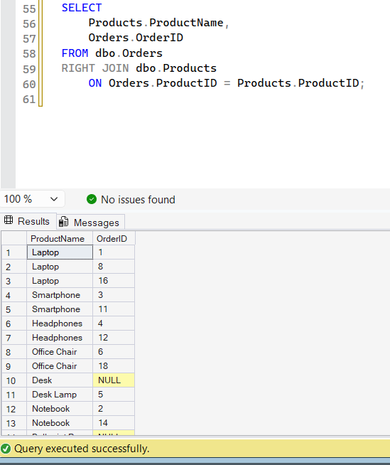

8.4 Display the FirstName and LastName of customers who have never placed any order.
select  Customers.FirstName,  Customers.LastName,  Orders.OrderID  from dbo.Customers  left join dbo.Orders  on Customers.CustomerID = Orders.CustomerID  where Orders.OrderID is null; | 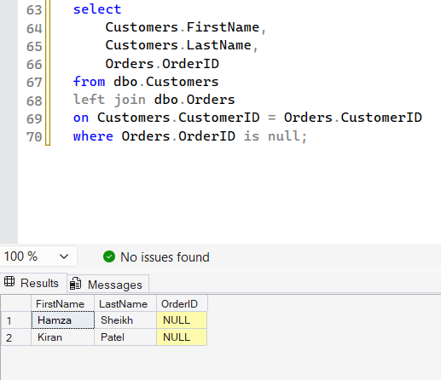

8.5 For all orders with Status 'Delivered', display the customer's FirstName, the ProductName, the OrderDate and the Quantity. (This needs three tables.)
select  Customers.FirstName,  Products.ProductName,  Orders.OrderDate,  Orders.Quantity  from dbo.Customers  join dbo.Orders  on Customers.CustomerID = Orders.CustomerID  join dbo.Products  on Orders.ProductID = Products.ProductID  where Orders.Status = 'Delivered'; | 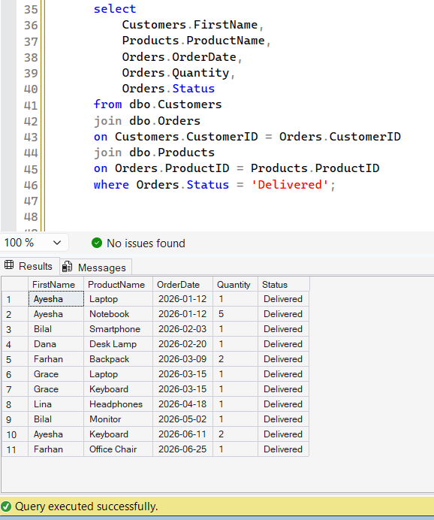

Part 9
9.1 Display ProductName and Price of products that cost more than the product 'Desk Lamp'. Use a subquery to find the price of the Desk Lamp (do not type the number yourself).
SELECT  productname,  price  from dbo.Products  where price >  (  select  price  from Products  where ProductName = 'Desk Lamp'  ); | 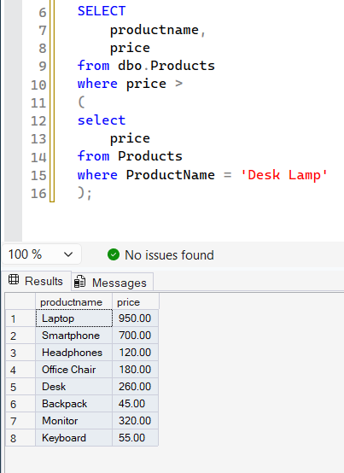

9.2 Display ProductName and Price of products that cost more than the average price of all products. (Hint: AVG(Price).)
select  productname,  price  from dbo.Products  where Price >  (  select  avg(price)  from Products  ); | 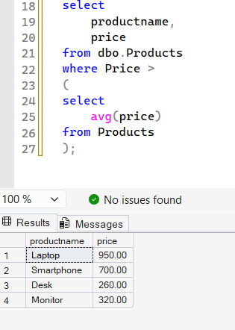

9.3 Display FirstName and LastName of customers who have placed at least one order. Use IN with a subquery on the Orders table.
select  firstname,  LASTname,  customerid  from dbo.Customers  where customerid in  (  select  Customerid  from dbo.Orders  ); | 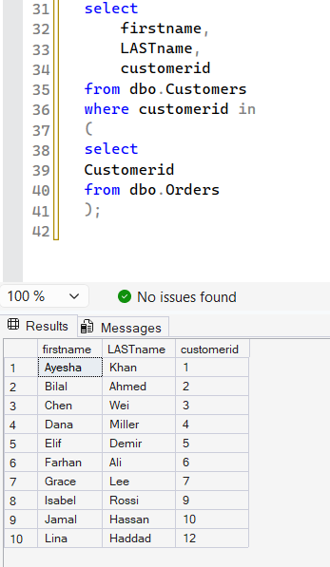

9.4 Display the ProductName of products that have never been ordered. Use NOT IN with a subquery.
select  Productname  from dbo.Products  where ProductID not in  (  select  ProductID  from dbo.Orders  ); | 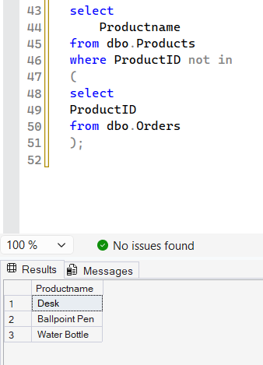

9.5 Challenge: Display FirstName and LastName of customers who have ordered at least one product from the 'Electronics' category. (Hint: a subquery inside a subquery.)
select  firstname,  lastname  from dbo.Customers  where CustomerID in  (  select  CustomerID  from dbo.Orders  where ProductID in  (  select  ProductID  from dbo.Products  where Category = 'electronics'  )  ); | 